1. Introduction 2
2. Objective 2
2.1 Primary Objectives 2
2.2 Secondary Objectives 2
3. Methodology 2
3.1 Selenium WebDriver (Chrome) 3
3.2 BeautifulSoup (bs4) 3
3.3 OpenPyXL 3
3.3 Pickle 3
3.4 Randomized Sleep Functions 3
3.5 Chrome Options / WebDriver Configuration 3
3.6 JavaScript Execution for Scrolling 3
4. System Architecture & Workflow 3
4.1 Profile URL Scraper 4
4.2 Profile Data Extraction 4
5. Major System Components 4
5.1 Human-Like Delay System 4
5.2 Cookie Management System 5
6. Limitation 5
6.1 Technical Limitations 5
6.2 Accuracy Limitations 5
7. Ethical & Legal Considerations 5
8. Conclusion 6

Introduction
LinkedIn has become an essential platform for modern recruitment, business intelligence, and market research, providing valuable insights into professional backgrounds, career paths, and organizational structures. However, manually collecting and analyzing large volumes of profile data is both time-consuming and inefficient. To address this challenge, a fully automated LinkedIn web-scraping system was developed using Python along with key libraries such as Selenium for browser automation, BeautifulSoup for HTML parsing, and OpenPyXL for structured data storage.
The system automates every stage of the data-collection process, including logging into LinkedIn, performing keyword-based searches for targeted roles such as CTO, CEO, or software developers, and scraping up to 2000+ profile URLs directly from search results. Once URLs are collected, the scraper visits each profile and extracts detailed information including the user’s name, headline, about section, education history, work experience, and professional certifications. All extracted data is then organized and saved into Excel files in a clean, structured format suitable for further analysis. This documentation provides a comprehensive overview of the workflow, architecture, methodologies, and technical components that drive this automated LinkedIn scraping solution.

Objective
The main objectives of the LinkedIn scraping automation are:

2.1 Primary Objectives
- Automate collection of large-scale LinkedIn profile URLs based on keyword search.
- Extract detailed user information from individual profile pages.
- Store scraped data into structured Excel spreadsheets.

2.2 Secondary Objectives
- Implement cookie-based login to avoid repeated authentication.
- Reduce detection risk through human-like behavior simulation.
- Ensure robustness against LinkedIn’s dynamic HTML structure.
- Build scalable logic to handle large datasets (2000+ profiles).

Methodology
The project utilizes several tools and technologies to ensure efficient, reliable, and human-like LinkedIn scraping:

3.1 Selenium WebDriver (Chrome)
- Used for browser automation
- Handles dynamic content, page interactions, and navigation
- Executes JavaScript for scrolling and element loading

3.2 BeautifulSoup (bs4)
- Parses HTML content retrieved from Selenium
- Extracts structured data such as name, experience, education, and about sections
- Handles complex LinkedIn DOM structures

3.3 OpenPyXL
- Reads and writes Excel files
- Stores scraped profile URLs and detailed extracted data
- Supports dynamic column creation based on varying profile information

3.3 Pickle
- Saves LinkedIn authentication cookies locally
- Enables automatic login without manual credentials
- Improves speed and reduces the risk of account lockouts

3.4 Randomized Sleep Functions
- Introduce human-like delays between actions
- Reduce the chances of automation detection
- Provide natural browsing behavior during scrolling, clicking, and loading

3.5 Chrome Options / WebDriver Configuration
- Customize browser behavior (e.g., maximize window)
- Improve performance and stability
- Manage cookies and simulation modes

3.6 JavaScript Execution for Scrolling
- Ensures lazy-loaded elements (Experience, Education, About) render fully
- Allows page content to load incrementally like a real user

System Architecture & Workflow
` The overall workflow of the scraping system consists of two major phases:

4.1 Profile URL Scraper
Purpose: Collect LinkedIn profile URLs using keyword search.
Steps:
- Load browser and attempt login via existing cookies.
- If cookies are invalid:
      - Perform manual login (one-time)
      - Save fresh cookies for future use.
- Perform LinkedIn search for keyword "CTO".
- Open “See all people results”.
- Visit each search results page:
  - Scroll multiple times.
  - Extract profile URLs.
  - Avoid duplicates using set-based filtering.
- Continue until 2000 unique profile URLs are collected.
Output:
- linkedin_profiles.xlsx containing raw profile URLs.
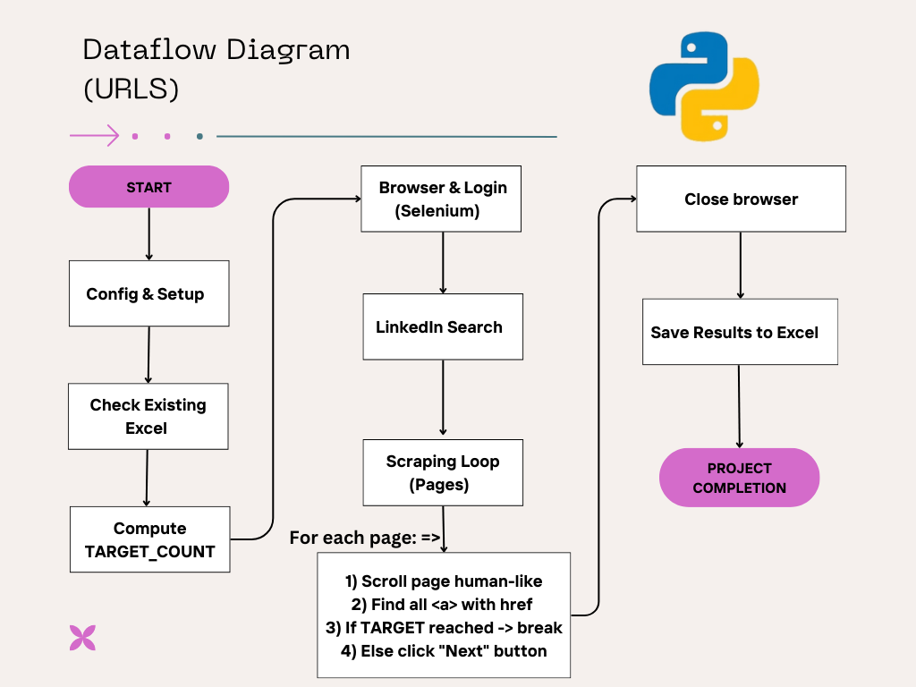

4.2 Profile Data Extraction
Purpose: Visit each profile and extract detailed information.
Steps:
- Load URLs from the Excel file.
- For each profile:
      - Visit the page
      - Scroll gradually to load dynamic content
      - Extract data using Selenium + BeautifulSoup
- Sections extracted:
      - Basic Info (Name, Headline)
      - About Section
      - Education
      - Experience
      - Certifications
- Save all profiles to:
      - Profiles_data.xlsx
      - Dynamically generate columns based on max counts

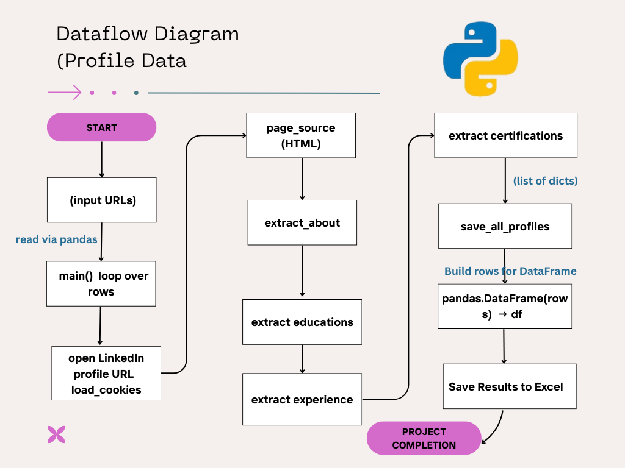

Major System Components

5.1 Human-Like Delay System
To avoid detection by LinkedIn:
- Random sleep between 6 – 12 seconds
- Short sleep (2 – 4 seconds)
- Gradual scrolling using JavaScript
- Randomized time intervals
This significantly reduces automation signatures.

5.2 Cookie Management System
Load Cookies
- Attempt login using previously stored cookies
- If cookies fail → fallback to manual login
Save Cookies
- Save new cookies after successful login
This reduces login actions and improves stability.

Limitation

6.1 Technical Limitations
- LinkedIn changes HTML structure frequently
- Heavy scrolling may cause slow extraction
- LinkedIn may temporarily restrict automation

6.2 Accuracy Limitations
- Some sections may not load fully
- Private profiles cannot be scraped
- Missing or inconsistent user data impacts output quality

Ethical & Legal Considerations
Scraping data from LinkedIn carries important ethical, legal, and compliance considerations that must be acknowledged before undertaking any automated data-collection activity. LinkedIn’s Terms of Service (TOS) explicitly prohibit unauthorized scraping, and violating these rules may result in account restrictions, legal action, or platform-level blocks. Additionally, data privacy regulations such as the GDPR in Europe and the CCPA in California impose strict rules on collecting, storing, and processing personal information without consent. Beyond legal frameworks, there is also an obligation to respect user confidentiality and protect individuals from unauthorized exposure of their professional data. For these reasons, scraped information must never be redistributed publicly or used in a way that compromises user privacy. Any data collected should be limited strictly to internal research or business analysis, ensuring that sensitive personal details are neither stored unnecessarily nor shared with third parties. Adhering to responsible use guidelines helps maintain ethical standards and reduces the risk of violating privacy expectations or regulatory requirements.

Conclusion
This project successfully automates the LinkedIn profile scraping process by integrating Selenium-based browser automation, dynamic scrolling techniques, HTML parsing with BeautifulSoup, and structured data export using OpenPyXL. Through features such as cookie-based login, human-like interaction patterns, and intelligent page navigation, the system is able to collect thousands of LinkedIn profiles efficiently while maintaining a high level of reliability. The resulting dataset offers valuable applications across various domains, including recruitment analytics, competitor benchmarking, professional research, and broader market insights. Looking ahead, the system can be further enhanced with AI-driven data cleaning, cloud-based scraping infrastructure for scalability, automated CAPTCHA detection mechanisms, and rotating user agents or proxy networks to improve anonymity and reduce the risk of detection.

